RIPHAH INTERNATIONAL UNIVERSITY ISLAMABAD

LAB 4
COMPILER CONSTRUCTION
SUBMITTED TO: MAM ASNAT
SUBMITTED BY FATIMA NAZIR-45317

TASK 1
DESIGN ADFA THAT STARTS WITH 1 AND END WITH 0
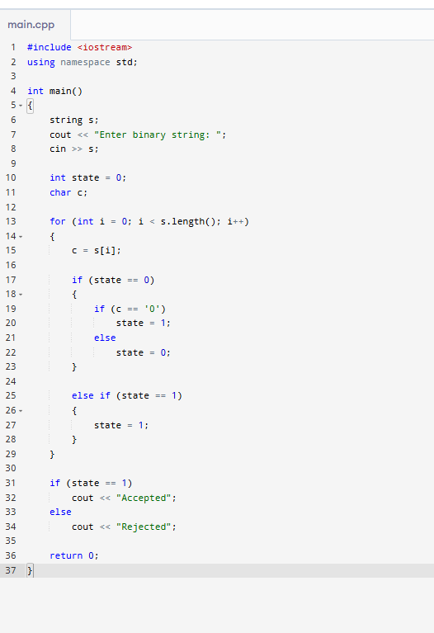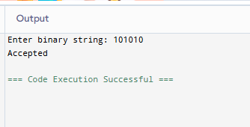
TASK 2
DESIGN A DFA THAT CONTAINS ATLEAST ONE ZERO
